8 DISTRIBUTION OF BOSE-EINSTEIN AND FERMI-DIRAC

In classical physics, the energy distribution of particles is described by the Maxwell distribution, which has the form:

$${dN}_{M}=A_{M}e^{-\frac{E_{k}}{kT}}{dp}_{x}{dp}_{y}{dp}_{z}$$ | (53)

Where Here A_{M} is a constant, which is determined from the normalization condition, E_{k} is the kinetic energy of the molecule. This distribution describes the state of a particle system that is not affected by external forces, and in which the particles do not interact with each other.
If the particle system is in an external potential field, then the Boltzmann distribution must be added to the Maxwell distribution, which has the form:

$${dN}_{Б}=A_{Б}e^{-\frac{U}{kT}}dxdydz$$ | (54)

Where U is the potential energy of the particle, T is the temperature, k is the Boltzmann constant, and A_{Б} are the normalization constants.
In the derivation of the statical distributions, the most probable distribution of particles is found, i.e. distribution that can be implemented in the largest number of methods. According to the basic postulate of statistical physics, this distribution corresponds to the equilibrium state of the system.
We will assume that the particles do not interact with each other (the ideal gas model), and also assume that all the distributions that lead to the same total energy of the particles are realized with the same probability.
In the derivation of the distributions in classical physics, it is considered that identical particles are fundamentally distinguishable. This, in particular, leads to the fact that the distribution, in which one of two identical particles - particle 1 is in state A, and the other - particle 2 is in state B, and the distribution, in which particle 1 is in state B, and particle 2 is in state A, are two different distributions.
In quantum mechanics, by virtue of the identity of identical particles, these two distributions should be considered one distribution. In addition, due to the difference in the properties of Fermi and Bose particles, the statistical distributions for these particles should differ significantly from each other.
Let’s illustrate the difference in the distribution of classical and quantum particles (fermions and bosons) in the following example. We need to distribute two particles in three states (cells). Classic particles, by virtue of their distinguishability, will be marked with the numbers 1 and 2. Quantum particles of the same kind are fundamentally indistinguishable, we will represent them as black circles. In this case, Fermi particles, in accordance with the Pauli prohibition, can be in each cell only one by one, and as for the Bose particles, then there are no restrictions on their distribution over the cells. The distribution results are shown in Figure 3.

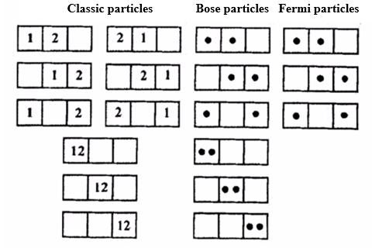
Figure 3 - Distribution of two particles in three states (cells)

For classical particles the number of possible distributions (microstates) is nine, and the probability of each of them is$\frac{1}{9}$. There are six distributions for Bose particles, respectively, the probability of each of them is$\frac{1}{6}$. For Fermi particles only three distributions are realized with a probability of falling out of each of them equal to$\frac{1}{3}$.

